Root Server Design Document

Security Classification: | Internal
Status: | Issued
Version: | 3.1
Team/Department : | Core Development/Networking Technology
Author(s): | Klaus Nielsen, Neil Maitland, Kevin Benton, Thomas Goodfellow
Owner(s): | Networking TA

Approver(s): | Networking TA | Distribution: | <Names>

Contents

1 Introduction 4
1.1 Purpose and Scope 4
2 Overview 4
3 Design 5
3.1 Client Library 5
3.1.1 Overview 5
3.1.2 API 5
3.1.2.1 Connect() 7
3.1.2.2 Version() 7
3.1.2.3 SetMBufPoolSize() 8
3.1.2.4 LoadCpm() 8
3.1.2.5 CancelLoadCpm() 9
3.1.2.6 UnloadCpm() 9
3.1.2.7 CancelUnloadCpm() 10
3.1.2.8 Bind() 10
3.1.2.9 CancelBind() 11
3.1.2.10 Unbind() 11
3.1.2.11 CancelUnbind() 12
3.1.2.12 GetModuleInfo() 12
3.1.2.13 EnumerateModules() 13
3.1.2.14 EnumerateSubModules() 14
3.1.2.15 EnumerateBindings() 15
3.1.2.16 SendMessage(TRequestStatus& aStatus, const TCFModuleName& aName, TInt aType, TDes8& aData) 16
3.1.2.17 SendMessage(const TCFModuleName& aName, TInt aType, TDes8& aData) 16
3.1.2.18 Shutdown() 16
3.1.3 Design Unit Behaviour 17
3.1.3.1 RRootServ 17
3.1.3.2 Connect 17
3.1.3.3 Version 17
3.1.3.4 SetMBufPoolSize 17
3.1.3.5 LoadCpm 17
3.1.3.6 CancelLoadCpm 17
3.1.3.7 UnloadCpm 17
3.1.3.8 CancelUnloadCpm 18
3.1.3.9 Bind 18
3.1.3.10 CancelBind 18
3.1.3.11 Unbind 18
3.1.3.12 CancelUnbind 18
3.1.3.13 GetModuleInfo 18
3.1.3.14 EnumerateModules 19
3.1.3.15 EnumerateSubModules 19
3.1.3.16 EnumerateBindings 19
3.1.3.17 Shutdown 19
3.1.3.18 SendMessage 19
3.1.4 Files 20
3.2 Root Server 20
3.2.1 Overview 20
3.2.2 UML Diagram 21
3.2.3 IPC Requests 23
3.2.3.1 RSLoadCPM 24
3.2.3.2 RSCancelLoadCpm 25
3.2.3.3 RSUnloadCPM 25
3.2.3.4 RSCancelUnloadCpm 27
3.2.3.5 RSBind 28
3.2.3.6 RSCancelBind 28
3.2.3.7 RSUnbind 29
3.2.3.8 RSCancelUnbind 29
3.2.3.9 RSGetModuleInfo 29
3.2.3.10 RSEnumerateModules 29
3.2.3.11 RSEnumerateSubModules 30
3.2.3.12 RSEnumerateBindings 30
3.2.3.13 RSSetMBufPoolSize 30
3.2.3.14 RSSendMessage 31
3.2.3.15 RSShutdown 31
3.2.4 Things not covered by the API 31
3.2.4.1 Spontaneous module/thread death 31
3.2.5 Starting the Root Server 32
3.2.6 Major Classes 33
3.2.6.1 CCommsProviderModule 33
3.2.6.2 CModuleUndertaker 33
3.2.6.3 CRootServer 34
3.2.6.4 CRootServerSession 35
3.2.6.5 CSessionResponse 35
3.2.7 Files 35
3.3 Bind Manager 36
3.3.1 Overview 36
3.3.1.1 Comms Server Process 36
3.3.2 Design 37
3.3.2.1 Interface 37
3.3.2.2 Basic Internal Architecture 39
3.3.2.3 CBindInfo object 40
3.3.2.4 CTask object 41
3.3.2.5 CModule object 42
3.3.2.6 BindSubmodulesL request 42
3.4 People 44
3.5 References 44
3.6 Glossary 44
3.7 Document History 44
3.8 Document Review Date 44
A.1.1 RootServer and Bind Manager separation issue 45

Figure 1: Threads and processes 4
Figure 2: The Root Server and modules 19
Figure 3: UML diagram for The Root Server and sessions 20
Figure 4: UML diagram for the modules 21
Figure 5: RSLoadCPM visualisation 23
Figure 6: RSUnloadCPM successfully visualisation 25
Figure 7: RSUnloadCPM with timeout visualisation 25
Figure 8: RSBind visualisation 26
Figure 9: Sudden Death visualisation 29
Figure 10 Components and Dependencies 34
Figure 11 Comms Server process 34
Figure 12 Component Class Diagram 37
Figure 13 CBindInfo 38
Figure 14 CTask 39

Introduction

Purpose and Scope
The purpose of this document is to show the detailed design for the Root Server component of Symbian OS v8.0. Furthermore the design of the Client Library providing control access to the Root Server is defined.
The design of other components introduced with Symbian OS v8.0, used by the Root Server, such as the MBuf Manager and the privileged reference application using the Root Server API (c32start.exe), are not within the scope of this document.

Overview
The Root Server is the component of the new Comms layer in Symbian OS v8.0, which has the responsibility of managing all other threads in the C32 process - the process running all Comms threads. As such, the Root Server is the main thread of the C32 process and it has the responsibility of starting and stopping server modules such as ESock, ETel and C32 (the Serial Server). Servers and non-server modules (sometimes referred to as providers) are treated as one entity in the Root Server, and will be referred to as CPM’s (Comms Provider Module) from this point in the document.
Manage
C32 Process
Root Server Thread
Provider Module Thread
User Process
Root Server Client Library
SymbianOS client/server IPC
Figure 1: Threads and processes
A CPM is a DLL with these attributes:
- The type (2nd UID) is KUidCommsProviderModule (0x101f7418)
- It exports a function which acts as the main function of a new thread, ie taking a single TCFModuleInfo* parameter and returning TInt when the CPM unloads. This function is called when the CPM is loaded and communicates with the Root Server across the Comms Channels provided in the TCFModuleInfo [1].
It is also the responsibility of the Root Server to monitor threads for Sudden Death (premature end of the thread routine) due to some erroneous condition. This is handled by using Publish and Subscribe, meaning that any privileged client that wish to be notified about such deaths must subscribe to the RProperty kept by the Root Server. Since all threads run in the same process the Root Server can only promise a best effort cleanup if a module dies. That means it can delete resources it knows of, but any resource allocated on the process heap by the dead module is lost (leaked). The only way to remedy this would be to run each module in a separate process but this is too heavy weight.
The Root Server will do nothing on its own initiative, however. Stopping and starting CPM’s has to be requested by a privileged application sending such requests via the Root Server Client Library. So has something not mentioned until now: bindings. It is possible for CPM's to be bound to each other (via the message queues provided in Symbian OS), hence providers can be bound together and providers can be bound to servers. A further responsibility of the Root Server is to receive such binding requests, verify the validity of the arguments and forward the requests for the Binding Manager component to carry out. The Binding Manager will be loaded within the Root Server thread.
A final note is that the Root Server will not implement any policy for restarting dead CPM’s. If a CPM dies, any subscribers to death are notified, and client applications will then have to figure out which CPM’s (any privileged client can query the Root Server for loaded modules) are dead (and how many) and what to do about it.
For efficiency reasons a client can have any number of pending requests with the Root Server at any given time. This means for example, that many CPM’s (of any type) can be started simultaneously and a CPM that is a slow starter will not delay the starting of any other CPM.

Design
The detailed design is broken into two parts (logically chosen by the IPC boundary):
- Client Library: Section 3.1. Describes the API offered by the client library to the Root Server and the corresponding IPC calls.
- Root Server: Section 3.2. Describes the architecture of the Root Server and how it interacts with the Binding Manager, the CPM’s and the client library.
In addition section 3.3 provides the design for the internal binding manager module, which is included by the Root Server as a static library.

Client Library

Overview
The client library provides the interface for user applications that have the appropriate privileges, to control the Root Server. More specifically the client library contains functions for the following Root Server control functions:
- Set the size of the MBuf pool.
- Load a Comms Provider Module from a DLL.
- Unload a Comms Provider Module.
- Create a binding between two Comms Provider Modules (hierarchical or custom). “Hierarchical” means that a module marked as server cannot be the lower module of the binding.
- Remove bindings between two Comms Provider Modules.
- Enumerate the loaded Comms Provider Modules.
- Enumeate the sub-modules under a Comms Provider Module.
- Enumerate Bindings for any given sub-module.
- Retrieve information of specific Comms Provider Modules.
- Listen for sudden death of loaded Comms Provider Modules.
- Send a message to the specified Comms Provider Module.
The client library will reside in its own DLL file called “c32root.dll”.
The APIs will be policed using CPolicyServer which CRootServerSession will derive from. Some of the following API functions will have capabilities restricting access to them.

API
In addition to the standard Symbian OS error codes the following can be returned:
KErrRSCreateTrapCleanup
KErrRSSvrStartServer
KErrRSMainSchedulerError
KErrRSSuddenDeath
KErrRSRequestCancelled
KErrRSInvalidParameter
KErrRSInvalidParameterFile
KErrRSInvalidParameterName
KErrRSInvalidParameterStackSize
KErrRSInvalidParameterHeapSize
KErrRSInvalidUidType
KErrRSModuleAlreadyExist
KErrRSInvalidMBufPoolSize
KErrRSModuleNotRunning
KErrRSModuleNotLoaded
KErrRSAlreadyBound
KErrRSModulesStillRunning
KErrRSNoNewHeapsAvailable
KErrRSRequestTimedOut
KErrRSModuleUnknown
KErrRSSubModuleUnknown
KErrRSBindingUnknown
KErrRSStatusUnknown
KErrRSBindingExists
KErrRSModuleNotReady
KErrRSBindingInProgress
KErrRSUnableToOpenHeap
KErrRSUnableToFindHeap
KErrRSUnableToCreateQueues
KErrRSZombie
KErrRSInvalidParameterThreadFuncOrdinal
KErrRSInvalidBinding
KErrRSInvalidQueueLength

A module can be in different states as defined by TRSModuleState:
- EIdle - Not running, probably just instantiated.
- EStarting - Started, waiting for rendezvous.
- ERunning - Running normally.
- EStopping - In the process of shutting down but thread still alive.
- EZombie- Thread suddenly died, in the process of cleaning up.
- EDead - Thread dead, in the process of being cleaned up.

The main client API class, RRootServ, defines the following interface, which is exported from c32root.dll:
TInt Connect();
TVersion Version() const;
TInt SetMBufPoolSize(TUint aPoolSize);
void LoadCpm(TRequestStatus& aStatus, const TRSStartModuleParams& aParams, const DesC8& aIniData);
void UnloadCpm(TRequestStatus& aStatus, const TCFModuleName& aName, TRSUnLoadType aType);
void Bind(TRequestStatus& aStatus, TRSBindingInfo& aBindInfo);
void Unbind(TRequestStatus& aStatus, TRSUnBindingInfo& aUnBindInfo);
TInt GetModuleInfo(const TCFModuleName& aName, TRSModuleInfo& aModuleInfo);
TInt EnumerateModules(TRSIter &aPosition, TCFModuleName& aModuleName);
TInt EnumerateSubModules(const TCFModuleName& aModuleName, TRSIter &aPosition, TCFSubModuleName& aSubModuleName);
TInt EnumerateBindings(const TCFSubModuleAddress& aSubModuleAddr, TRSIter &aPosition, TRSBindingInfo& aBinding);
void CancelLoadCpm(const TCFModuleName& aName);
void CancelUnloadCpm(const TCFModuleName& aName);
void CancelBind(TRSModuleAddress& aName1, TRSModuleAddress& aName2);
void CancelUnbind(TRSModuleAddress& aName1, TRSModuleAddress& aName2);
void SendMessage(TRequestStatus& aStatus, const TCFModuleName& aName, TInt aType, TDes8& aData);
TInt SendMessage(const TCFModuleName& aName, TInt aType, TDes8& aData);
TInt Shutdown();
void Close();

TInt __DbgMarkHeap();
TInt __DbgCheckHeap(TInt aCount);
TInt __DbgMarkEnd(TInt aCount);
TInt __DbgFailNext(TInt aCount);
TInt __DbgFailNextMbuf(TInt aCount);
TInt __DbgSetMbufPoolLimit(TInt asize);
TInt __DbgCheckMbuf(TInt asize);
TInt __DbgMbufFreeSpace();
TInt __DbgMbufTotalSpace();

The following sections will describe each API function in more detail and how to use it.
All __Dbg functions will require a Vendor ID of 0x70000001 (Symbian Vendor ID) and ensure that the caller has a capability of “Networkcontrol”.

Connect()
TInt Connect();

Description:

Opens a session to the Root Server.

Notes:
- Synchronous.
- Close() should be called once the session is no longer required. All resources, which are opened using the session, will be automatically closed when the session terminates.

Return value:
TInt | KErrNone if successful, otherwise one of the global error codes or a code defined in Rserror.h.

Version()
IMPORT_C TVersion Version() const;

Description:

Gets the version of this client.

Notes:
- Synchronous.

Return value:
TVersion | Client side version number.

SetMBufPoolSize()
TInt SetMBufPoolSize(TUint aPoolSize);

Description:

Set the size of the MBuf pool.

Notes:
- Synchronous.
- This function can only be called before the first CPM is loaded.

Capability:
The SID will be checked to ensure that this request came from the comms configurator.

Parameters:
TUint aPoolSize | Defines the new size of the buffer pool in number of bytes.

Return value:
TInt | KErrNone if successful, otherwise one of the global error codes or a code defined in Rserror.h.

LoadCpm()
void LoadCpm(TRequestStatus& aStatus, const TRSStartModuleParams& aParams, const TDesC8& aIniData);

Description:

Launch a new Comms Provider Module. This may be a server (e.g.ESOCK) or a provider from a DLL.

Notes:
- Asynchronous.
- The name of the new CPM (aParams.iParams.iName) must be unique and must be used in any further communication concerning this CPM instance, such as binding.
- The contents of the initialisation data parameter (aIniData) are specific to the CPM. It could be empty, contain the contents of an associated INI file or contain some other data specified by the specific CPM implementation.
- If a CPM fails to complete startup – ie. By not responding to its discovery request for sub-modules, the load will fail with ERSZombie. This error code is used to convey the idea that this CPM is in a state of living dead – loaded but not responding. It is recommended that the client follow such a load failure by issuing an ungraceful UnloadCpm() in order to remove the CPM.

Capability:
The SID will be checked to ensure that this request came from the comms configurator.

Parameters:
TRequestStatus& aStatus | KErrNone if successful, otherwise one of the global error codes or a code defined in Rserror.h.
TRSStartModuleParams& aParams | Parameters used for CPM thread.
TDesC8& aIniData | CPM specific initialisation data.

CancelLoadCpm()
void CancelLoadCpm(const TRSModuleName& aName);

Description:

Cancel the launch of a new Comms Provider Module.

Notes:
- Synchronous.
- It is unlikely that the CPM loading is cancelled.

Capability:
The SID will be checked to ensure that this request came from the comms configurator.

Parameters:
const TRSModuleName& aName | Name of module of which to cancel loading.

UnloadCpm()
void UnloadCpm(TRequestStatus& aStatus, const TRSUnLoadInfo& aUnLoadInfo);

Description:

Unload a Comms Provider Module.

Notes:
- Asynchronous.
- If the CPM in question has bindings to other CPM’s they will be removed automatically before the CPM is asked to unload.
- The three defined values of aUnLoadInfo::iType are:
- EOptional – module is requested to gracefully shut down unless it has a good reason not to (such as active clients of its own)
- EGraceful – module is instructed to gracefully shut down
- ENonGraceful – module thread is immediately terminated
- For EOptional and EGraceful requests the client status is completed with whatever code the CPM thread returned or exited with, or KErrTimeout if the thread fails to exit.
- For ENonGraceful the CPM thread requests the client status is completed with KErrCancel.

Capability:
The SID will be checked to ensure that this request came from the comms configurator.

Parameters:
TRequestStatus& aStatus | One of the global error codes (eg KErrNone) or a code defined in Rserror.h., as above.
TRSModuleName& aName | The name of the module to be unloaded (specified with LoadCpm() and type of unload.

CancelUnloadCpm()
void CancelUnloadCpm(const TRSModuleName& aName);

Description:

Cancel a previously made unload request.

Notes:
- Synchronous.
- It is unlikely that the CPM unloading is cancelled, but a best effort will be made and the pending UnloadCpm() request will be completed immediately.

Capability:
The SID will be checked to ensure that this request came from the comms configurator.

Parameters:
const TRSModuleName& aName | Name of CPM of which to cancel unloading.

Bind()
void Bind(TRequestStatus& aStatus, TRSBindingInfo& aBindInfo);

Description:

Binds two CPM’s.

Notes:
- Asynchronous.
- Several types of bindings are available:
- EHierarchical: Standard top-bottom bindings in the protocol hierarchy. If this type is specified aName1 is considered top-level module of the binding and aName2 is considered bottom-level part. Also this type of binding allow that the top-level CPM is a server.
- ECustom: Horizontal binding between two CPM’s. Typical use is when a CPM employs another CPM to do some processing and communicates via the standard message queues.
- The other binding types specified in TRSBindType (EControl and ESap) are illegal to use with Bind() as they are purely generated by the CPM’s and Comms Servers themselves. They might however, be returned with the GetBindingInfo() command.

Capability:
The SID will be checked to ensure that this request came from the comms configurator.

Parameters:
TRequestStatus& aStatus | KErrNone if successful, otherwise one of the global error codes or a code defined in Rserror.h.
TRSBindingInfo& aBindInfo | Type of binding to perform, names of modules involved.

CancelBind()
void CancelBind(const TRSModuleName& aName1, const TRSModuleName& aName2);

Description:

Cancel the binding of two CPM.

Notes:
- Synchronous.
- It is unlikely that the binding is cancelled, but a best effort will be made and the pending Bind() request will be completed immediately.

Capability:
The SID will be checked to ensure that this request came from the comms configurator.

Parameters:
const TRSModuleName& aName1 | First CPM of the pending binding.
const TRSModuleName& aName2 | Second CPM of the pending binding.

Unbind()
void Unbind(TRequestStatus& aStatus, TRSModuleName& aName1, TRSModuleName& aName2);

Description:

Unbinds two CPM’s.

Notes:
- Asynchronous.
- If the CPM’s are not bound does nothing.
- If the CPM’s have more than one binding all are unbound.

Capability:
The SID will be checked to ensure that this request came from the comms configurator.

Parameters:
TRequestStatus& aStatus | KErrNone if successful, otherwise one of the global error codes or a code defined in Rserror.h.
TRSModuleName& aName1 | CPM to unbind from aName2
TRSModuleName& aName2 | CPM to unbind from aName1

CancelUnbind()
void CancelUnbind(const TRSModuleName& aName1, const TRSModuleName& aName2);

Description:

Cancel the unbinding of two CPM’s.

Notes:
- Synchronous.
- It is unlikely that the unbinding is cancelled, but a best effort will be made and the pending UnBind() request will be completed immediately.

Capability:
The SID will be checked to ensure that this request came from the comms configurator.

Parameters:
const TRSModuleName& aName1 | First CPM of the pending unbinding.
const TRSModuleName& aName2 | Second CPM of the pending unbinding.

GetModuleInfo()
TInt GetModuleInfo(TRSModuleName& aName, TRSModuleInfo& aModuleInfo);

Description:

Get information about one CPM – Name, Dll filename, State and number of sub-modules.

Notes:
- Synchronous.

Parameters:
TRSModuleName& aName | Name of CPM. Same name as specified in LoadCpm().
TRSModuleInfo& aModuleInfo | CPM information

Return value:
TInt | KErrNone if successful, otherwise one of the global error codes or a code defined in Rserror.h.

EnumerateModules()
TInt EnumerateModules(TRSIter& aPosition , TCFModuleName& aModuleName);

Description:
Return a list of running CPM’s one at a time. The client must poll the Root Server over and over until the names of all modules have been returned.

Parameters:
TRSIter& aPosition | Position in enumeration. In/out parameter
TCFModuleName& aModuleName | Memory area within which to put the returned TCFModuleName. Out parameter, allocated by the caller.

Return value:
TInt | KErrNone if successful, KErrEof after reaching the end of the enumeration (in which case aModuleName is not updated), otherwise one of the global error codes or a code defined in Rserror.h.

Example usage:
TRSIter position;
TCFModuleName moduleName;
// Query a previously connected Root Server instance and do something
while(KErrNone == iRootServer->EnumerateModules(position , moduleName))
{
// Do something with moduleName
}

Notes:
- Synchronous.
- The names are returned in no particular order.
- aPosition is an in/out parameter. It is intentionally opaque. Should an invalid iterator be passed (eg one for a different enumeration) then an error is returned, rather than a panic resulting.
- No state is preserved by the Root Server for the enumeration; the client can abandon it before the end or restart it without consequence.
- The enumeration returned is not a snapshot from the start and is not stable against change: if modules are loaded or unloaded during the enumeration then an error might be returned or a module could be skipped or returned twice.

EnumerateSubModules()
TInt EnumerateSubModules(const TCFModuleName& aModuleName, TRSIter& aPosition TCFSubModuleName& aSubModuleName);

Description:
Return a list of sub-modules belonging to a module, one at a time. The client must poll the Root Server over and over until the names of all sub-modules have been returned.

Parameters:
const TCFModuleName& aModuleName | Module whose sub-modules are being enumerated. In parameter.
TRSIter& aPosition | Position in enumeration. In/out parameter
TCFSubModuleName& aSubModuleName | Memory area within which to put the returned TCFModuleName. Out parameter, allocated by the caller.

Return value:
TInt | KErrNone if successful, KErrEof after reaching the end of the enumeration (in which case aSubModuleName is not updated), otherwise one of the global error codes or a code defined in Rserror.h.

Example usage:
TRSIter position;
TCFSubModuleName subModuleName;
// Query a previously connected Root Server instance and do something
while(KErrNone == iRootServer->EnumerateSubModules(iModule, position, subModuleName))
{
// Do something with subModuleName
}

Notes:
- Synchronous.
- The names are returned in no particular order.
- aPosition is an in/out parameter. It is intentionally opaque. Should an invalid iterator be passed (eg one for a different enumeration) then an error is returned, rather than a panic resulting.
- No state is preserved by the Root Server for the enumeration; the client can abandon it before the end or restart it without consequence. The client should not change the TCFModuleName during the enumeration; doing so will probably return an error and at best will produce a jumble of sub-modules.
- The enumeration returned is not a snapshot from the start and is not stable against change: if the parent module was unloaded during the enumeration then the next call to EnumerateSubModules() will return an error rather than the next member.

EnumerateBindings()
TInt EnumerateBindings(const TCFSubModuleAddress& aSubModuleAddr, TRSIter& aPosition TRSBindInfo& aBindInfo);

Description:
Return a list of bindings of sub-modules of the nominated module. The client must poll the Root Server over and over until the names of all sub-modules have been returned.

Parameters:
TCFSubModuleAddress& aSubModuleAddr | Sub-modules to enumerate the bindings of.
TRSIter& aPosition | Position in enumeration. In/out parameter
TRSBindInfo& aBindInfo | Memory area within which to put the returned TRSBindInfo. Out parameter, allocated by the caller.

Return value:
TInt | KErrNone if successful, KErrEof after reaching the end of the enumeration (in which case aBindInfo is not updated), otherwise one of the global error codes or a code defined in Rserror.h.

Example usage:
TRSIter position;
TRSBindInfo bindInfo;
// Query a previously connected Root Server instance and do something
while(KErrNone == iRootServer->EnumerateSubModules(iSubModule, position, bindInfo))
{
// Do something with bindInfo
}

Notes:
- Synchronous.
- The bindings are returned in no particular order.
- aPosition is an in/out parameter. It is intentionally opaque. Should an invalid iterator be passed (eg one for a different enumeration) then an error is returned, rather than a panic resulting.
- No state is preserved by the Root Server for the enumeration; the client can abandon it before the end or restart it without consequence. The client should not change the TCFSubModuleAddress during the enumeration; doing so will probably return an error and at best will produce a jumble of bindings.
- The enumeration returned is not a snapshot from the start and is not stable against change: ie if new bindings are made or existing ones removed during the enumeration then an error might be returned or a binding could be skipped or returned twice.

SendMessage(TRequestStatus& aStatus, const TCFModuleName& aName, TInt aType, TDes8& aData)
void RRootServ::SendMessage(TRequestStatus& aStatus, const TCFModuleName& aName, TInt aType, TDes8& aData);
Description:
Sends a message to the specified CPM. The message is supposed to be based on CNetMessage class.

Parameters:
TRequestStatus& aStatus | A request status for the asynchronous operation. KErrNone on successful completion.
TCFModuleName& aName | The name of the CPM that receives the message.
TInt aType | Specifies the type of data in aData parameter. Possible types are defined in TCFMessageType enum.
TDes8& aData | A data specific to the message and it's type given by aType parameter. The data is expected to be CNetMessage based serialised instance.

Notes:
- Asynchronous.
- Result code: if the module name is wrong, KErrRSModuleUnknown is returned; If the message format is wrong, KErrArgument is returned. Otherwise this is the result of the message processing.

SendMessage(const TCFModuleName& aName, TInt aType, TDes8& aData)
TInt RRootServ::SendMessage(const TCFModuleName& aName, TInt aType, TDes8& aData);
The same as above, but synchronous version.

Return value:
TInt | The result of synchronous message sending. KErrNone on success.

Notes:
- Synchronous.
Example usage:
// Create TPtr8 from the buffer with message’s data
TPtr8 ptr(some buffer with message’s data);

// Construct a message
NetMessages::CMessage message;
User::LeaveIfError(message.Store(ptr));

// Send a message to the module, which name is represented by iModule.
User::LeaveIfError( iC32Root.SendMessage( iModule, CommsFW::EFactoryMsg, ptr ));

Shutdown()
TInt Shutdown();

Description:

If no modules are loaded it shuts down the RootServer and exit the Comms Process (c32exe.exe).

Notes:
- Synchronous.
- If modules are still loaded it returns KErrRSModulesStillRunning and the RootServer keeps running. It is the responsibility of the client to unload all modules.
Capability:
The SID will be checked to ensure that this request came from the comms configurator.

Design Unit Behaviour
The Root Server client library is no more than an IPC abstraction and no overall design is needed. The following chapters will contain implementation notes on the individual functions in the RRootServ API class.

RRootServ
Default constructor. Does nothing

Connect
Create new session to the Root Server by using parent RSessionBase::Connect() and return result.

Version
Create new TVersion object with the client library version number (a function) and return it.

SetMBufPoolSize
Send a synchronous request to Root Server and return result.
IPC request: | RSSetMBufPoolSize
Parameter | Type | Data source
Parameter 0 | TUint | aPoolSize

LoadCpm
Send asynchronous request to Root Server, using aStatus and return.
IPC request: | RSLoadCpm
Parameter | Type | Data source
Parameter 0 | TRSStartModuleParams& | aParams
Parameter 1 | TDesC8 | aIniData

CancelLoadCpm
Send asynchronous request to Root Server, using aStatus and return.
IPC request: | RSCancelLoadCpm
Parameter | Type | Data source
Parameter 0 | TRSModuleName& | aName

UnloadCpm
Send asynchronous request to Root Server, using aStatus and return.
IPC request: | RSUnloadCpm
Parameter | Type | Data source
Parameter 0 | TRSModuleName& | aName
Parameter 1 | TRSUnLoadType | aType

CancelUnloadCpm
Send synchronous request to Root Server, using aStatus and return.
IPC request: | RSCancelUnloadCpm
Parameter | Type | Data source
Parameter 0 | TRSModuleName& | aName

Bind
Send asynchronous request to Root Server, using aStatus and return.
IPC request: | RSBind
Parameter | Type | Data source
Parameter 0 | TRSBindType | Type
Parameter 1 | TRSModuleName& | aName1
Parameter 2 | TRSModuleName& | aName2

CancelBind
Send synchronous request to Root Server, using aStatus and return.
IPC request: | RSCancelBind
Parameter | Type | Data source
Parameter 0 | TRSModuleName& | aName1
Parameter 1 | TRSModuleName& | aName2

Unbind
Send asynchronous request to Root Server, using aStatus and return.
IPC request: | RSUnBind
Parameter | Type | Data source
Parameter 0 | TRSModuleName& | aName1
Parameter 1 | TRSModuleName& | aName2

CancelUnbind
Send synchronous request to Root Server, using aStatus and return.
IPC request: | RSCancelUnbind
Parameter | Type | Data source
Parameter 0 | TRSModuleName& | aName1
Parameter 1 | TRSModuleName& | aName2

GetModuleInfo
Send synchronous request to Root Server and return result.
IPC request: | RSGetModuleInfo
Parameter | Type | Data source
Parameter 0 | TRSModuleName& | aName
Parameter 1 | TRSModuleInfo& | aModuleInfo

EnumerateModules
Send synchronous request to Root Server, using aStatus and return.
IPC request: | RSEnumerateModules
Parameter | Type | Data source
Parameter 0 | TRSIter& | aPosition
Parameter 1 | TCFModuleName& | aModuleName

EnumerateSubModules
Send synchronous request to Root Server, using aStatus and return.
IPC request: | RSEnumerateSubModules
Parameter | Type | Data source
Parameter 0 | const TCFModuleName& | aModuleName
Parameter 1 | TRSIter& | aPosition
Parameter 2 | TCFModuleName& | aModuleName

EnumerateBindings
Send synchronous request to Root Server and return result.
IPC request: | RSEnumerateBindings
Parameter | Type | Data source
Parameter 0 | const TCFSubModuleAddress& | aSubModuleAddr
Parameter 1 | TRSIter& | aPosition
Parameter 2 | TRSBindInfo& | aBindInfo

Shutdown
Send synchronous request to Root Server and return result.
IPC request: | RSShutdown

SendMessage
Sends a message to the specified CPM synchronously or asynchronously.
IPC request: | RSSendMessage
Parameter | Type | Data source
Parameter 0 | const TCFModuleName& | aName
Parameter 1 | TInt | aType
Parameter 2 | TDes8& | aData

Files
File | Description
rsshared.h | The API classes from section 3.1.2, apart from RRootServ.
c32root.h | Includes rsshared.h. Definition of RRootServ.
c32root.cpp | The API implementation described in section 3.1.3.
rserror.h | Root Server error codes.
c32root.dll | The client library binary.

Root Server

Overview
The Root Server is the main thread of the new C32 Process and until the privileged client application requests loading of the first CPM it is also the only thread. The main purpose of the Root Server is to carry out creation and shutdown of CPMs, on request, and to use the Binding Manager to bind them together.
The Root Server implements the server side of the API/tools for configuring the CPMs running within the C32 process. More specifically the server implements the server part of the services described in section 3.1.2.
In order to do this the Root Server has to maintain a list of all CPMs that are active. This means registering/de-registering them from internal data structures at load/unload time as well as keeping an eye on them in case of spontaneous thread death (). It only keeps an eye on the thread the CPM in question was created with. If the CPM has created its own threads it is of no concern to the Root Server.
The Root Server is also the main (and the only) user of the Binding Manager, which runs in the same thread as the Root Server. The Root Server creates a BindMgr instance from “bindmgr.dll” (to which it is statically linked) when first needed (when first CPM is started). It is also the job of the Root Server to notify the Binding Manager of CPM’s loaded/unloaded and to forward user requests for bindings to the Binding Manager.
The Binding Manager will have ownership of all control message queues, so when the Root Server has successfully started a CPM it must pass the associated queues to the Binding Manager along with a unique handle identifying the thread. The handle is associated with an object saved in the Root Server, representing the CPM. Whenever the Root Server client library makes a request (e.g. ERSBind) it refers to the CPM in question with a string name which is then used to find the object representing the CPM, and its unique handle which is used internally and in communication with the Binding Manager.
C32 Process
Server specific client library
Provider Module Thread
Root Server Client library
Binding Manager component (DLL)
MBuf Manager component (DLL)
Reference to Provider Module Thread
Reference to Provider Module Thread
Root Server
Comms Channels
Thread creation/control
Client/server IPC
Comms Channels
Provider Module Thread
Figure 2: The Root Server and modules

Using friendly symbolic names instead of handles in the Client API is all right in this context because none of the functions provided are time critical. It doesn’t matter from a performance perspective that each API call has to match the string name with a handle or even whether it uses a sub-optimal data structure for matching names/handles.
The design of the MBuf Manager is not within the scope of this document.
As mentioned earlier, Sudden Death notification is now handled by Publish and Subscribe. The Root Server keeps an RProperty member which is the sudden death property and a TInt counter which records the number of deaths as they happen. Each time the Root Server is informed of a death, the property is published and all clients which have subscribed to this property are notified.

UML Diagram
igure 3 depicts the basic structure of the Root Server implementing the required SymbianOS client/server classes. Please notice that the Root Server holds the Binding Manager instance, the MBuf Manager instance, a list of Sudden Death listeners (objects to be notified if a thread dies) and most notably: The list of Comms Provider Modules.
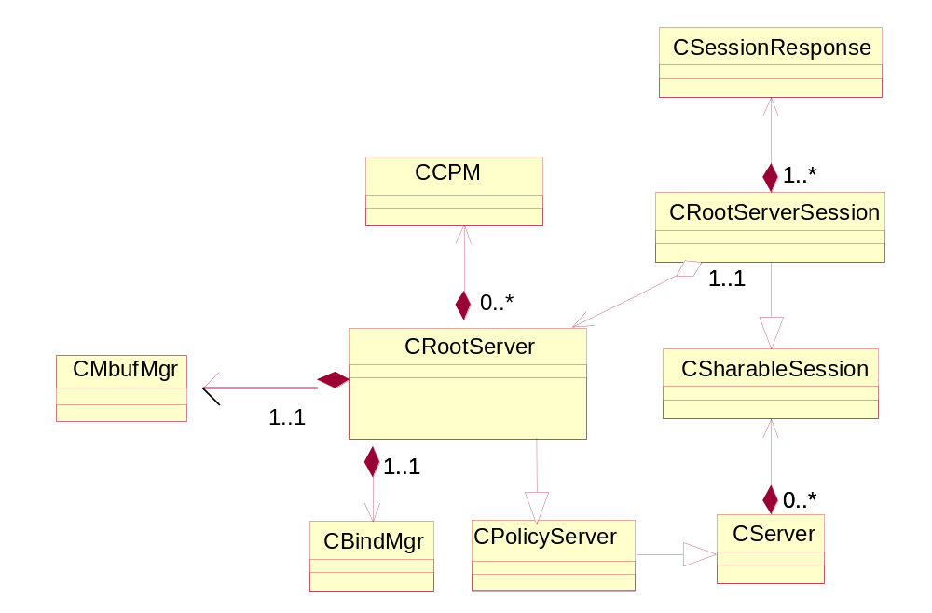
igure 3: UML diagram for The Root Server and sessions

The following table provides a quick overview.
Object name | Description
CCPM | Object representing a loaded/running Comms Provider Module.
CRootServer | The required server implementation in the SymbianOS client/server model.
CRootServerSession | The required session implementation in the SymbianOS client/server model.
CBindMgr | Bind Manager instance.
CMbufMgr | MBuf Manager instance.

Figure 4 depicts the structure of the class representing a running thread: CCommsProviderModule. It provides the required tools to control a CPM thread. There is a timer active object for actions requiring a timer (e.g.
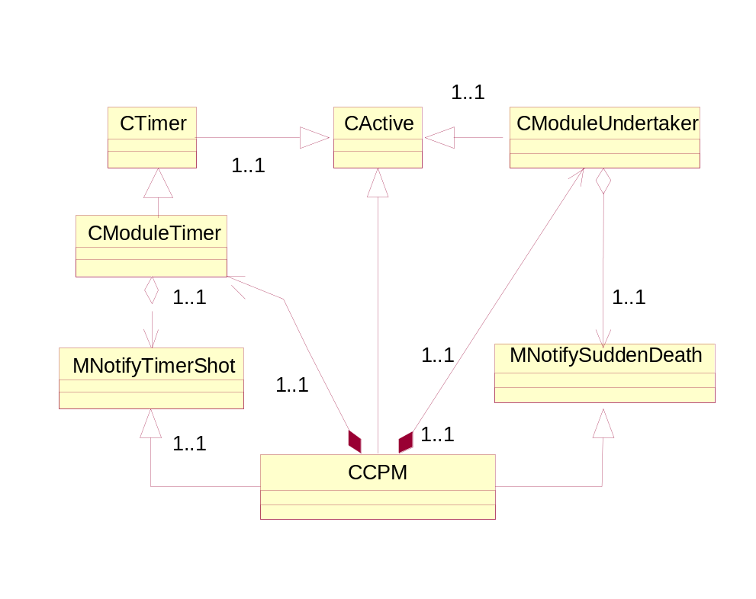Figure 4: UML diagram for the modules

shutting down a thread), an undertaker to monitor the thread for Sudden Death (prematurely ending thread-function) and an active object for asynchronous feedback from other modules, e.g. the Binding Manager. Thus the CPM instance becomes a fairly autonomous entity. To control all this the CPM entity will contain a state member variable, in effect being an informal state-event machine (i.e. no central state-event function, but still dependent on a state concept).

The following table provides a quick overview.
Object name | Description
CCommsProviderModule | Class for CPM’s. Owns information such as name, dll filename, identifying unique handle, thread object and the current state of the CPM.
CModuleTimer | Providing CTimer functionality to the modules.
MNotifyTimerShot | Timer notification interface implemented by CModuleBase.
CModuleUndertaker | Class listening for sudden module thread death by means of a RUndertaker object.
MNotifySuddenDeath | Framework for notifying of thread death, this interface is implemented by CModuleBase.

IPC Requests
In the following each supported IPC request will be described, including the algorithms implementing it. Even though out-of-memory handling is not mentioned in the algorithms it is extremely important to remember handling all possible out-of-memory as well as error conditions and propagate the error-codes to the client application where applicable.
For robustness the CServer2 framework (using TIpcArgs for parameter transfer) is used.

RSLoadCPM
IPC parameters defined in section 3.1.3.5.
Required SID of the client: SID of c32start.exe.

Algorithm:
- Check that new module name is not already known and that the second UID of the DLL to load is 0x101f7417.
- If no Bind Manager, create a new instance from factory in bindmgr.dll.
- Retrieve a new Queue-pair for control queues (they need to be available when the thread is spawned).
- Create a new CCommsProviderModule instance for the new CPM.
- Tell the CCommsProviderModule instance to start the module, waiting for it to complete by means of the CSessionResponse active object.
- The CCommsProviderModule will:
- Check that the state is EIdle, else complete immediately with an error.
- Set the state to EStarting.
- Start thread.
- Wait for rendezvous or thread failure/death.
- If success do a thread logon using the iUndertaker member of the new CCommsProviderModule instance.
- Notify Bind Manager of the new server and pass ownership of the associated control queue-pair and the handle representing the server instance.
- Set the state to ERunning.
- Complete the active object (CSessionResponse) with a completion code.
- Upon activation of the CSessionResponse instance, complete RMessage with result.

Figure 5 depicts the informal sequence diagram for the algorithm.
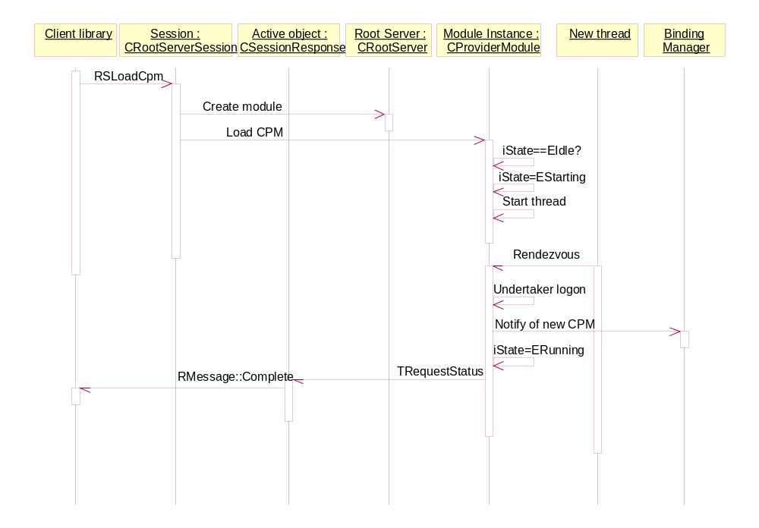Figure 5: RSLoadCPM visualisation

RSCancelLoadCpm
IPC parameters defined in section 3.1.2.5.
Required SID of the client: SID of c32start.exe.

Algorithm:
- Go through list of session handlers to identify the pending matching one.
- I handler is found.
- Complete RMessage with result.

RSUnloadCPM
IPC parameters defined in section 3.1.3.6.
Required SID of the client: SID of c32start.exe.

Algorithm:
- If CPM exists, get instance and:
- Check if the sticky bit is set and if so complete immediately with KErrLocked
- Else tell CCommsProviderModule to unbind all, waiting for it to complete by means of the CSessionResponse active object.
- The CPM will:
- Check that the state is ERunning, else complete immediately with an error.
- Set the state to EStopping.
- Ask Bind Manager to asynchronously unbind all bindings to self.
- When complete received ask Binding Manager to send CPMShutdown message to CPM. Unless there was an error in which case it should be propagated to the waiting session object.
- Wait (timed) for CPM thread to end. If timeout notify client.
- If CPM thread ended notify Binding manager of module death
- Complete the active object (CSessionResponse) with the completion code.
- Delete self.
- Complete RMessage with result.

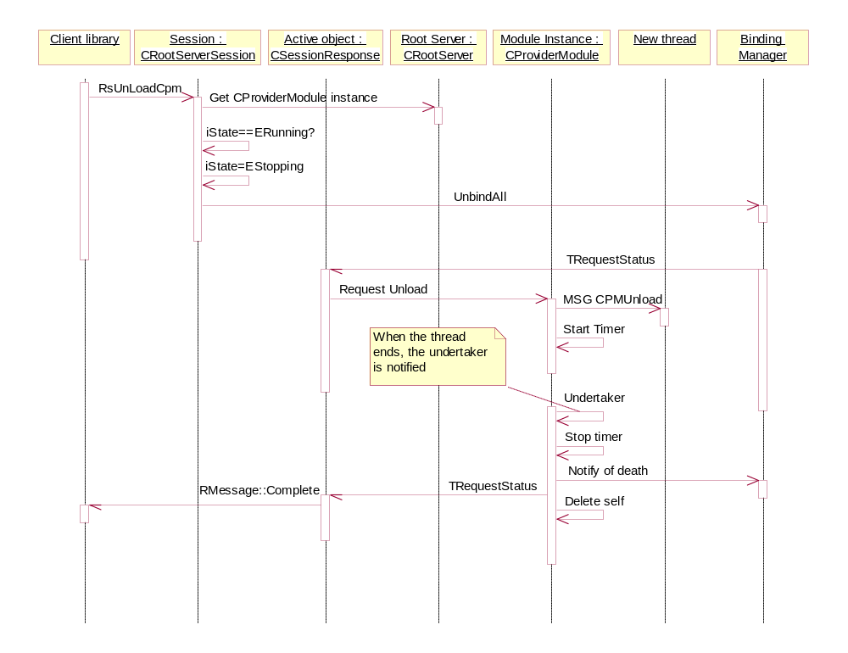
Figure 6 depicts a sequence where the threads terminates peacefully before the timeout and Figure 7 depicts the situation where the thread does not end as requested and the timer is shot. Notice that in both cases the undertaker is triggered when the thread is finally dead.
Figure 6: RSUnloadCPM successfully visualisation

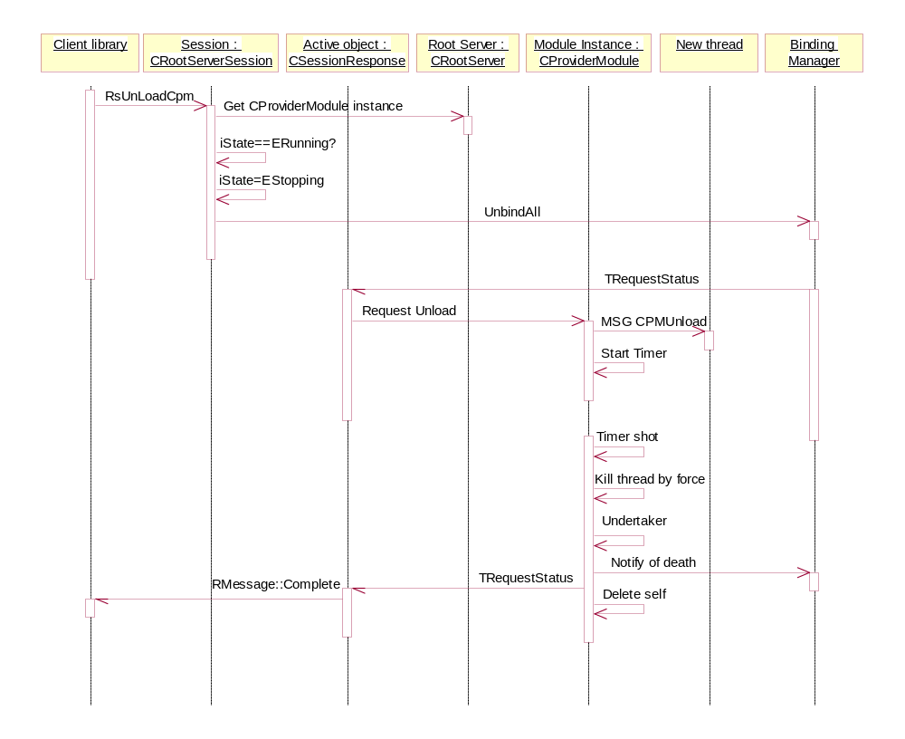
Figure 7: RSUnloadCPM with timeout visualisation

RSCancelUnloadCpm
IPC parameters defined in section 3.1.2.7.
Required SID of the client: SID of c32start.exe.

Algorithm:
- Go through list of session handlers to identify the pending matching one.
- I handler is found.
- Complete RMessage with result.

RSBind
IPC parameters defined in section 3.1.3.8.
Required SID of the client: SID of c32start.exe.

Algorithm:
- Check that both CPM names exist.
- Pass request to Bind Manager, waiting for it to complete by means of the CSessionResponse active object.
- When completed, complete RMessage with result.

depicts the informal sequence diagram for the algorithm.

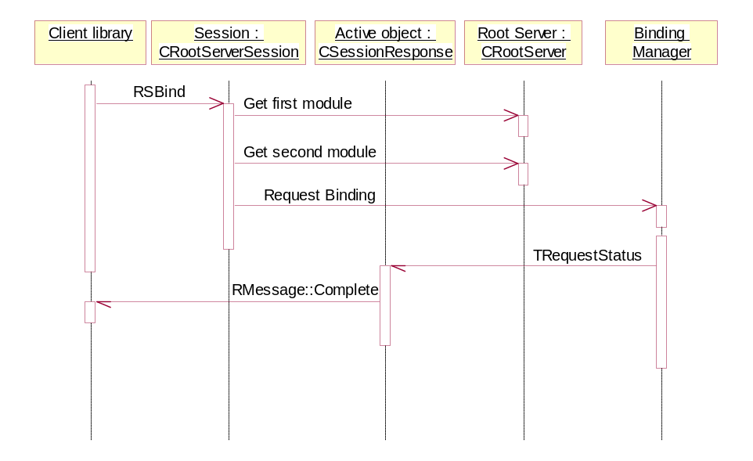
Figure 8: RSBind visualisation

RSCancelBind
IPC parameters defined in section 3.1.2.9.
Required SID of the client: SID of c32start.exe.

Algorithm:
- Go through list of session handlers to identify the pending matching one.
- I handler is found.
- Complete RMessage with result.

RSUnbind
IPC parameters defined in section 3.1.3.10.
Required SID of the client: SID of c32start.exe.

Algorithm:
- Check that both CPM names exist.
- Pass request to Bind Manager, waiting for it to complete by means of the CSessionResponse active object.
- When completed, complete RMessage with result.

RSCancelUnbind
IPC parameters defined in section 3.1.2.11.
Required SID of the client: SID of c32start.exe.

Algorithm:
- Go through list of session handlers to identify the pending matching one.
- I handler is found.
- Complete RMessage with result.

RSGetModuleInfo
IPC Parameters defined in section 3.1.3.13.
Required UID of the client: No UID requirement.

Algorithm:
- Check that the CPM name is valid (by retrieving a reference from the CRootServer instance).
- Query the Binding Manager (synchronously) for the binding info for the CPM.
- Fill a TRSModuleInfo structure with the appropriate values and copy it into Parameter 1
Complete RMessage with result.

RSEnumerateModules
IPC Parameters defined in section 3.1.3.12.
Required UID of the client: No UID requirement.

Algorithm:
- Retrieve the current enumeration position from Parameter 1
- Retrieve enumeration for Comms Provider Modules from the CRootServer instance.
- If successful, copy the TCFModuleName to Parameter 2 and write the incremented position to Parameter 1.
- Complete RMessage with result.

RSEnumerateSubModules
IPC Parameters defined in section 3.1.3.12.
Required UID of the client: No UID requirement.

Algorithm:
- Retrieve the module name from Parameter 1 and the current enumeration position from Parameter 2.
- Retrieve enumeration for sub-modules from the CRootServer instance.
- If successful, copy the TCFSubModuleName to Parameter 3 and write the incremented position to Parameter 2..
- Complete RMessage with result.

RSEnumerateBindings
IPC Parameters defined in section 3.1.3.15.
Required UID of the client: No UID requirement.

Algorithm:
- Retrieve the sub-module address from Parameter 1 and the current enumeration position from Parameter 2.
- Using a CBindManager instance, iterate the bindings for the sub-module address to find the given position.
- If successful, copy the TRSBindInfo to Parameter 3 and write the incremented position to Parameter 2.
- Complete RMessage with result.

RSSetMBufPoolSize
IPC Parameters defined in section 3.1.3.4.
Required SID of the client: SID of c32start.exe.

Algorithm:
- Check if RMBufPool already instantiated; if so, result is KErrInUse. Check desired size against constant min & max boundaries; if exceeded then result is ERSInvalidMBufPoolSize. If no errors then record desired size for the subsequent lazy instantiation.
Complete RMessage with result.

RSSendMessage
IPC Parameters defined in section 3.1.3.16 and 3.1.3.17
Algorithm:
- Retrieve the module name from Parameter 1
- Call CRootServer::Forward() method, passing there the CPM name and the reference to the message
- Root Server in turn calls CBindManager::SendL
- The Bind manager finds an appropriate module by its name and calls its method SendL, passing a message as a parameter.
- The CPM completes the message.

If the module name is wrong, the message will be completed with KErrRSModuleUnknown code, if the message format is wrong, the completion code will be KErrArgument, otherwise the result will be formed by the module that processed the message.

RSShutdown
IPC Parameters defined in section 3.1.3.18.
Required SID of the client: SID of c32start.exe.

Algorithm:
- If CPMs are still loaded result = KErrRSModulesStillRunning
- Otherwise shutdown Root Server
- Complete RMessage with result.

Things not covered by the API

Spontaneous module/thread death
In case of sudden thread death the CModuleUndertaker object associated to the CPM will be activated. The RunL member will call the notification member (which is a CCommsProviderModule::SuddenDeath()), which will implement the following algorithm:
- Set status to EZombie.
- Notify Binding Manager of death and request to asynchronously unbind bindings between all CPM’s and the dead one using BindMgr::UnbindDead().
- Wait for binding manager to complete unbinding.
- Call the CRootServer Sudden Death member, which publishes its Sudden Death RProperty – the number of CPM’s to have died.
- Remove self from the list and delete self.

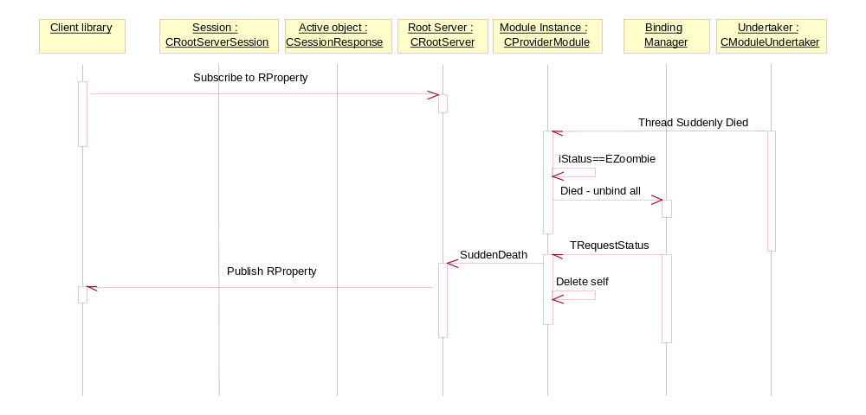Figure 9 depicts the informal sequence of Sudden Death handling using Publish and Subscribe.
Figure 9: Sudden Death visualisation

The client is not notified which client has died, but can retrieve the number of deaths by calling the get() function of the RProperty published by the Root Server.

Starting the Root Server
Executing the application c32exe.exe starts the Root Server. The c32exe.exe as implemented by c32exe.cpp, will contain the following main function:
GLDEF_C TInt E32Main()
{
return RunRootServer(); // Load Root Server. Blocks by starting the active scheduler
}

TInt RunRootServer() function is the main thread routine for the Root Server, living in the c32rootsrv.dll It will initialise the actual Root Server object and then start the Active Scheduler. This is the algorithm:
- Set thread parameters: proper priority and protected thread.
- Create and initialise a CRootServer instance.
- If everything was all right start the Active Scheduler. Otherwise return error-code.
Note: The MBufMgr instance will not be created until the first time it is needed.
In Symbian OS v8.0 the name of the privileged reference application configuring the Comms process via the Root Server API will be c32start.exe. Since we have to start the Root Server sometime, it seems reasonable to let c32start.exe be responsible for executing c32exe.exe, thus starting the C32 process/Root Server before it starts configuring the server and provider modules.
The RunRootServer routine is protected against being called repeatedly, so there is no damage done here.
The function StartC32() that previously lived in c32.dll now is moved to c32root.dll. This function is critical to clients who wish to connect to the Root Server. In order to use the Root Server, it must be fully configured and ready, and StartC32 will endeavour to ensure this is so. A synchronous Publish and Subscribe method is used, with StartC32 first starting c32start.exe if the configuring state property does not exist, then waiting for c32start.exe to publish that property to indicate that the Root Server is configured. At this point all servers are deemed up and running.
It is important to note, that if a second caller of StartC32 enters while the first is still being processed, it must be blocked and only return when the Comms process is fully configured and ready to run. This will happen by that call waiting for the configured property to be published. Any called of StartC32 must expect to have a fully configured system when the call returns.

Major Classes
In the following sections the major class will be listed. However, only the most important/interesting member functions and variables will be shown here. For a full reference, please look at the headerfiles.

CCommsProviderModule
This is the main cpm class orchestrating thread creation, loading and unloading, The class is asynchronously activated from three active objects: its own derivative, a timer it owns (iModuleTimer) and the undertaker associated with the thread (iUndertaker member). The type of action taken on a particular input is decided by its internal state, defined by an iState member.

The public interface of the class contains the following members:
static CCommsProviderModule* NewL(CRootServer* aRootServer, TCFModuleName& aName, TFileName& aDll, TThreadPriority& aPriority, TInt aStackSize, TUint& aMinHeapSize, TUint& aMaxHeapSize, HBufC8* aIniData, TBool& aPrivateHeap);

~CCommsProviderModule();
TInt Load(); // Start module in new thread
TInt Unload(TRequestStatus& aStatus); // Unload module
TInt GetHandle(); // Get thread handle
TModuleName& GetName();
TFileName& GetDll();
TModuleState GetState();
virtual void SuddenDeath(TInt aReason); // Called by iUndertaker upon thread death
virtual void ModuleTimerShot(); // Called by iModuleTimer

Key member data (private):
TModuleState iState; // Current state of module (running, starting, etc)
TQueuePair iQueuePair; // Queues given to the module at initialisation
TCFModuleName iName; // Name of module, defined by privileged app
RLibrary iLibrary; // Keeping the DLL so it can be closed at unload
RCFThread iThread; // Thread handle of running module context
CModuleUndertaker* iUndertaker; // Active object listening for sudden death
CRootServer* iRootServer; // Access to the root server
TDblQue<CNotifySuddenDeathContainer> iNotifiers; // Registered sudden death notifiers
TRSTransientModuleInfo* iThreadStartupInfo; // Holds inidata, etc.
RHeap* iHeapPtr; // Pointer for the heap associated with the thread
};

CModuleUndertaker
The CModuleUnderTaker class monitors a thread for sudden death. If it happens it will call SuddenDeath() on it's iNotifier member. It uses the standard RThread.Logon() for this purpose.

The public interface of the class contains the following members:
~CModuleUndertaker();
static CModuleUndertaker* NewL(MNotifySuddenDeath* iNotifier, RThread* aThread);
void Logon(); // Logon to the thread to watch
void LogonCancel(); // Cancel thread logon

Key member data (private):
MNotifySuddenDeath* iNotifier; // Interface which has a SuddenDeath() member.

CRootServer
This is the main Root Server class and must only exist in one instance in the process. It initialises and holds the instance of the MBuf Manager as well as lists of the loaded modules/threads in the C32 process. It is derived from CPolicyServer.

The public interface of the class contains the following members:
static CRootServer* NewL(TInt aPriority, TUint aMbufPoolSize);

// Create new CRootServerSession instance
virtual CSharableSession* NewSessionL(const TVersion &aVersion) const;

// Create Comms Provider module and put it in list
CCommsProviderModule* CreateCpmL(TRSStartModuleParams& aParams, HBufC8* aIniData);

// Retrieve Server or Provider reference by name or handle
CCommsProviderModule* FindCpm(const TRSModuleName& aName);
CCommsProviderModule* FindCpm(TInt aHandle);

// Remove modules from queues and delete them
TInt DeleteCpm(TInt aHandle);

// Sudden Death notification. Called by Undertaker's. Will cause publication of
// Sudden Death property.
void SuddenDeath(TInt aReason);

// Information, module count
TInt CpmCount();

// Information, Enumeration
TInt Enumerate(TDes8& aList);

TInt GetModuleInfo(const TRSModuleName& aName, TRSModuleInfo& aInfo);

// forward a message “aMessage” to the CPM with name “aModule” via Bind Manager
TInt Forward(const TCFModuleName& aModule, const RMessage2& aMessage);

Key member data (private):
TUint iMbufPoolSize; // Size of MBuf Pool to be used when loading the MBufMgr
TDblQue<CCommsProviderModule> iModules; // List of active (or known) modules
CMBufManager* iMBufManager; // MBuf Manager when created, otherwise NULL

CRootServerSession
Required session object as required by the client/server framework, derived from CSession2. Implements the IPC API. Keeps a list of asynchronous event handlers (see 3.2.6.5).

The public interface of the class contains the following members:
CRootServerSession(const CRootServer* aRootServer);
virtual void ServiceL(const RMessage& aMessage);
void RegisterHandler(CSessionHandler& aHandler); // Save a handler managing a client request
void CloseSession();
CRootServer* RootServer(); // Get the Rootserver
RMessage& GetMessage();
~CRootServerSession();

void PanicClient(const RMessage& aMessage, TInt aError);

The private section of the class contains the following members for internal use:
// Member functions implementing IPC functionality
TInt SetMBufPoolSize(const RMessage& aMessage);
TInt LoadCPML(const RMessage& aMessage);
TInt UnloadCPML(const RMessage& aMessage);
TInt BindL(const RMessage& aMessage);
TInt UnbindL(const RMessage& aMessage);
TInt GetModuleInfo(const RMessage& aMessage);
TInt EnumerateModules(const RMessage& aMessage);
TInt EnumerateSubModules(const RMessage& aMessage);
TInt EnumerateBindings(const RMessage& aMessage);
TInt CancelLoadCPM(const RMessage& aMessage);
TInt CancelUnloadCPM(const RMessage& aMessage);
TInt CancelBind(const RMessage& aMessage);
TInt CancelUnbind(const RMessage& aMessage);
TInt Shutdown(const RMessage& aMessage);
TInt Forward(const RMessage2& aMessage);

Key member data (private):
TDblQue<CSessionHandler> iActiveHandlers; // List of handlers currently servicing
// client requests

CSessionResponse
Active session handler object. Used when the session makes an asynchronous request to e.g. Binding Manager. Has access to public members of it's CRootServerSession parent. CRootServerSession will keep a list of these, one for each pending asynchronous request. Derives from CActive.
The public interface of the class contains the following members:
CSessionHandler(CRootServerSession* aSession, RMessage& aMessage);
TDblQueLink iLink; // DblQue link element, for storing in the session

Key member data (private):
CRootServerSession* iSession; // Parent session instance

Files
A table of source files (.cpp / .h)
File | Description
rserror.h | Root Server error codes.
rsshared.h | The definitions shared with the client library. The content of this file is defined in section 3.1.4.
rsstd.h | Classes and definitions.
policy.h | API Policing policy defiitions
rootsrv.cpp | Implementation of the CRootServer class.
rootsess.cpp | Implementation of the root server session class.
rootutil.cpp | Implementation of all utility classes besides server and session classes such as CCommsProviderModule, and whatnot.
c32rootsrv.dll | The Root Server binary, which is loaded by c32exe.exe.
c32exe.exe | The application launching the Root Server, becoming the process having the Root Server as main thread.
c32exe.cpp | Source for c32exe.exe.

Bind Manager

Overview
The Bind Manager is the component owned by Root Server thread, with the responsibility of managing all relevant information concerning binding among Comms Provider Modules. It communicates with these modules (throughout RCFChannel objects of Comms Channels component) in order to perform bind/unbind operations.
As Bind Manager owns the communication channels between Root Server and CPM’s, any Root Server message (other then bind instructions – see [1]) will also go through this component. Figure 10 shows Bind Manager and its neighbouring components.
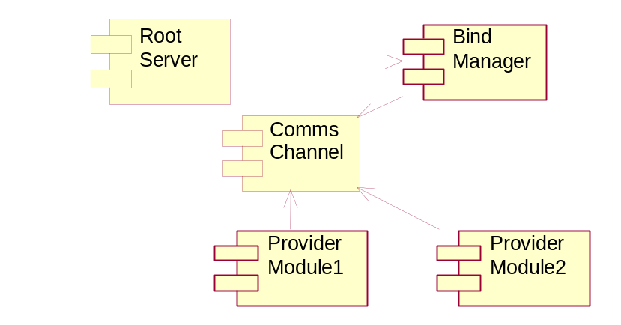
Figure 10 Components and Dependencies

Comms Server Process
As shown at Figure 10, the process contains the following threads:
- RootServer, that contains Bind Manager module;
- A number of CPM threads. They are uniquely identified by the module name such as “esock:” and “etel:” at the figure. They can contain a number of sub-modules. Sub-modules are identified by the name in form module_name:submodule_name.
Channels among RootServer (i.e. Bind Manager) and modules are created on module creation and are used to carry messages such as those to bind/unbind particular sub-modules. See document [1] for the full list of messages.
In order to create protocol stacks, any two sub-modules can be bound to each other and communicate using a private message interface. Consider a hypothetical scenario where ESock has a ProtMan submodule and tcpip6 runs in a different thread with each protocol as a sub-module (Figure 11). Bind Manager owns all channels on the figure. The module channels would be created by the RootServer, when the module is started and the sub-module to sub-module channel by Bind requests.
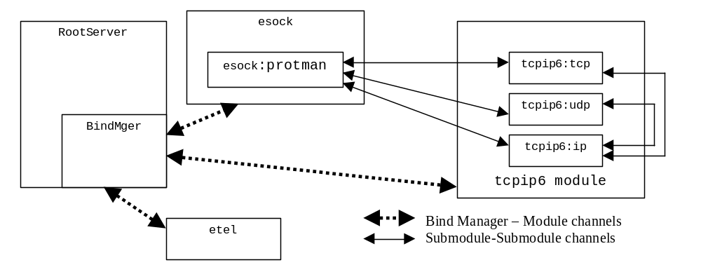
Figure 11 Comms Server process

Design
The design of Bind Manager is based upon the following requirements:
- There will be a single instance of the component running under active scheduler framework.
- It will be used by Root Server component (thread) only i.e. concurrency is not an issue.
- The component should be able to accept and maintain any number of requests at the same time.
- The requests containing TRequestStatus as an input parameter are supposed to complete in a definite time (with the status indicating timeout if it occurs).
- The design should provide mechanism to cancel any outstanding operation in a safe manner. Also, any cancelled request has to be able to resume – if another identical request arrives from RootServer.
- The messages towards CPMs must not be duplicated. If a requests of RootServer requires a message to be sent to a module and the same massage is already sent (and reply has not arrived yet) as result of a previous request, no another message will be sent to the module.

Interface
Bind Manager component will be instantiated by creation of an object of the class CBindManager. Therefore, the class interface represents the interface of the component and it is as follows:

NewL
static CBindManager* CBindManager::NewL(MRootserverNotify& aRootServerNotifier)
Creates an instance of CBindManager, leaving if already created.
The input argument will serve to transfer to Root Server all messages coming from server/provider modules that are not part of bind/unbind process and have to be passed directly to Root Server rather then being processed by Bind Manager.

CreateModuleL
void CreateModuleL(TRequestStatus& aStatus,
const TCFModuleName& aModule,
const RCFChannel aInputQueues,
const RCFChannel aOutputQueues);
Creates module access point that will control (send and receive) messages from/to server/provider module. The Bind Manager will become responsible for the RCFChannels and should close them when the module is deleted. The Bind Manager will issue a Discovery message to the module and await a valid DiscoveryResp before complete the request.

BindSubmodulesL
TInt BindSubmodulesL(TRequestStatus& aStatus,
const TRSBindType aType,
const TCFSubModuleAddress& aUpperSubmodule,
const TCFSubModuleAddress& aLowerSubmodule);
Creates binding between two sub-modules. They can be ether the part of the same module or belong to different ones.
“aType” represents the type of binding as defined in [1].

UnbindSubmodulesL
void UnbindSubmodulesL(TRequestStatus& aStatus,
const TCFSubModuleAddress& aUpperSubmodule,
const TCFSubModuleAddress& aLowerSubmodule);
Unbinds two sub-modules.

UnbindAllFromModuleL
void UnbindAllFromModuleL(TRequestStatus& aStatus,
const TCFModuleName& aModule);
Unbinds all bindings that involve the module defined by the input argument.

UnbindAlreadyDeadModuleL
void UnbindAlreadyDeadL(TRequestStatus& aStatus,
const TCFModuleName& aModule);
Unbinds all bindings that involve the module defined by the input argument. As the module is presumed dead, the messages are sent to other modules only.

UnbindAllAndShutDownL
void UnbindAllAndShutDownL(TRequestStatus& aStatus,
const TCFModuleName& aModule);
Unbinds all bindings that involve the module defined by aModule and sends shut down message to the module.

ModuleEndedL
void ModuleEndedL(const TCFModuleName& aModule);
Delete module access point created by CreateModuleL(). It will be also used as the final trigger to finish UnbindAndShutDownL() request (if a such request is previously issued).

SendL
void SendL( const TCFModuleName& aModule, const RMessage2& aMessage );
Sends the message to the server/provider module as specified by the input arguments. Bind Manager is not concerned by the content of the message.

CancelL
void CancelL(TRequestStatus& aStatus);
Cancels pending request defined by the input argument.

NumBindings
TInt NumBindingsL(const TCFSubModuleAddress& aSubModule,
TInt& aBindingNo);
Returns the number of bindings with the specified sub-module or a complete module if the submodule name in the parameter is empty (ie zero length). Returns an error code if the module/sub-module is not found, otherwise KErrNone.

BindingInfoL
void BindingInfoL(const TCFSubModuleAddress& aSubModule,
RCFBindInfoPointerArray& aInfo);
Returns information about bindings of the sub-module specified in the parameter, or a complete module if the submodule name in the parameter is empty (ie zero length).This is in the form of an array of pointers to binding information, which consists of the two bound modules, the binding type, the state of each binding, and any status codes returned by the sub-modules during the bind operation. The data pointed to is const and owned by the BindManager class. However, the array itself is owned by the calling function and should be Closed when no longer required.

Basic Internal Architecture
The class diagram showing the basic concept of the design is at Figure 12.
CBindManager object keeps the list of modules (CModule objects) in the system.
CModule has the messaging channels, owned by the RootServer (iSendChannel and iRecvChannel) to particular module and the list of all tasks (messages) that have been sent to the module and are waiting for a reply. CModule (as an active object) is always pending on receiving channel from the module (through iRecvChannel object).
The list of CBindInfo keeps the current state of bindings and it is updated every time a new Root Server request is received or a server/provider module reply arrives, or a job timeout occurs.
CJob list represents all current requests in progress. A CJob contains the list of TaskId+CModule tuples defining all of the tasks that belong to given job. Also, it owns a CJobTimeout object that will generate Timeout() event after a period, ending the request with TimeoutOccured status.

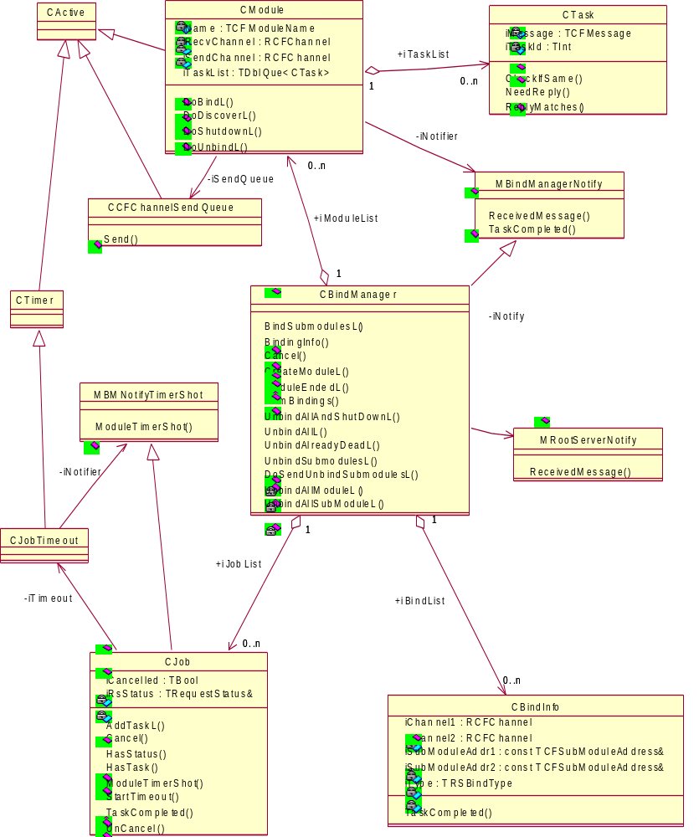
Figure 12 Component Class Diagram

CBindInfo object
This object contains information about a particular binding and owns the communication channels between two modules (CommsChannel1 and CommsChannel2).
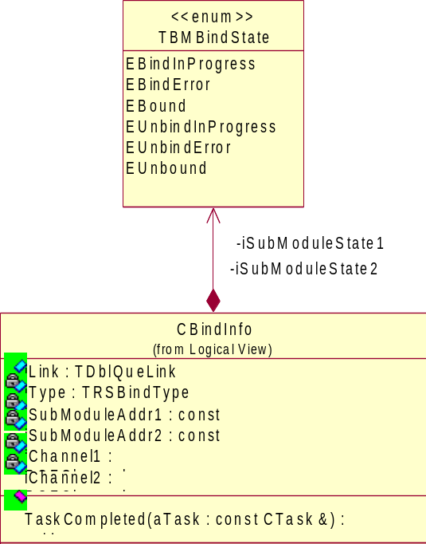
Figure 13 CBindInfo
It is created by the BindManager and added to its iBindList when a Bind request is received from the RootServer. iState1 and iState2 hold the binding state of both ends. The possible values are:
- EBindInProgress(=0). The BindRequest message has been sent to the module but a confirmation has not arrived.
- EBindError(=1). Either the server/provider module has replied with a status other then KErrNone, or it has not replied before the job timeout.
- EBound(=2). Module is bound (a positive confirmation has arrived).
- EUnbindInProgress(=3). Message is sent to the module to unbind but the conformation has not arrived yet.
- EUnbindError(=4). Server/provider module replied with a status different then KErrNone, or it has not arrived at all within defined interval.
- EUnbound(=5). Module is unbound (conformation has arrived).
The object will be removed from the list and deleted when:
- Both states are unbound, or
- Module (CModule object) involved in the binding is about to be deleted.
CBindInfo objects will be used to provide information necessary for:
- Defining the list of CTask objects that are created on any bind/unbind request;
- NumBinding() and BindingInfo() requests;
- Validation on any bind/unbind request.

CTask object
They represent messages that are sent to server/provider modules and are created by CBindManager object on arrival of Root Server request to bind or unbind. While BindSubmodulesL() and UnbindSubmodulesL() requests always require two tasks to be completed (sending a message to both peers), request such as UnbindAll() may create a number of CTasks objects as it depends on current binding state in the system recorded by CBindInfo list.
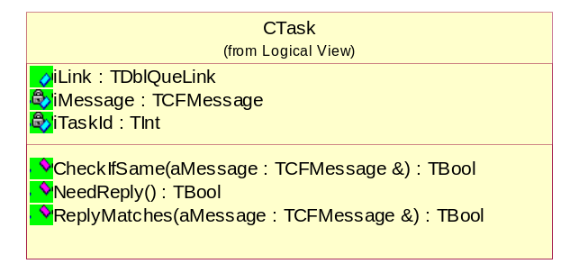
Figure 14 CTask
Once the object is created and a message is sent by CModule object, CTask object lives in task list of particular CModule until reply from the module arrives or timeout for particular CJob object (request) occurs. The object is then passed back to CBindManager along with the status (where it will be used to update CBindInfo objects) and destroyed.
The object is able to generate TCommMesage structure that has to be sent to the module. Also, it can recognise if reply from the module matches the message that it represents.

CModule object
These are created by the BindManager when it receives a CreateModuleL() request. Once the CModule object is created, the BindManager will automatically start a Discover job on the CModule to determine which sub-modules it contains. This list is then stored in each CModule and used to validate all Bind requests.
Before creating a new task, the message is checked against each of the existing tasks in the CModule (using the CTask::CheckIfSame method) and if a match is found then the TaskId of the existing task is returned to the BindManager. Otherwise a new task is created and its TaskId returned.
When a new task is created, the CModule will also construct and send the associated message to the server/provider module.
The SendMessage() method allows BindManager to send a message directly to the the server/provider module, without using the Task structures.

CModules are active objects, and once created will call the asynchronous NotifyDataAvailable() function on their receive queues. When a message is received, it will be checked against all the existing tasks in the reply list and if matches any, BindManager will be notified using the TaskCompleted upcall. If it does not match any replies, then the generic ReceivedMessage upcall will be used.

BindSubmodulesL request
The following are sequence diagrams for Bind request that cover several scenarios. As the sequence of the events in the component does not really depend on which request is called, the figures bellow could serve as description of any CBindManager public method call to bind/unbind. The diagrams do not show the events and messages within CModule objects, as they are already explained.
On BindSubmodulesL() request, Bind Manager will perform the following tasks:
- Validates request, checking that the modules exist, and that no completed binding (ie bind states set to Bound) exists.
- Request the modules (or module) to create the bind tasks. If a matching task is already in progress, then the module will return its TaskId, otherwise it will create a new task with a new Id and send the message to the module.
- See if there is an existing ca ncelled CJob with the same set of TaskIds by calling the UnCancelIfHasTasks() method on each CJob. If the CJob matches, then it resets its Cancelled flag and sets its Status object to the new request.
- If no job is Uncancelled, the a new CJob object will be created with the TaskIds and added to the TaskList.
- The StartTimeout method of CJob is called.
The request will be completed when all tasks are met (ie confirmation received from both submodules), the CJob times out, or a cancel request is received – whichever happens first.
When a task is completed, all CJob object in the BindManager’s list will be informed in order to update their lists of tasks (actually just a list of TaskIds). When a CJob has no more outstanding tasks it completes the RootServer’s RequestStatus, Cancels the timeout (not strictly necessary) and deletes itself.
All CBindInfos must also be told of each completed task so that they can update the status of each binding.

People
Role | Person / People
Contributor(s)
Reviewer(s) | Thomas Goodfellow, Stephen Larkin, Philippe Gabriel.

References
No. | Document Reference | Version | Description
 | SGL.GT0167.nnn | Latest | Comms Framework Message API

Glossary
The following technical terms and abbreviations are used within this document.
Term | Definition
CPM | Comms Protocol Module

Document History
Date | Version | Status | Description
2002-07-24 | 0.5 | Ready for review | Updated after review by Thomas Goodfellow and Stephen Larkin.
2002-07-29 | 0.6 | Ready for review | Updated after review by Philippe Gabriel.
2002-12-12 | 1.3 | ISSUED | Added UID requirements for client API.
2002-12-13 | 1.4 | Issued | [Neil Maitland] Added design of Bind Manager.
2003-04-05 | 1.8 | Issued | Removed specific project names in favour of targeted OS release.
2003-04-10 | 1.9 | DRAFT | [TG] Added TRSUnLoadType::EOptional
2003-05-28 | 2.2 | DRAFT | [TG] Changed EnumerateModuleI), EnumerateSubModue() EnumerateBinding() to stateless model
2003-06-06 | 2.3 | DRAFT | [TG] Switched enumeration iterator to TRSIter
2003-07-01 | 2.6 | DRAFT | [TG] Switched to trivial shutdown (client has responsibility of unloading modules)
2003-07-16 | 2.7 | DRAFT | [TG] Improved description of CPM
2003-09-24 | 2.8 | DRAFT | Update after review.
2003-11-08 | 2.9 | ISSUED
2004-07-09 | 3.0 | DRAFT | Added API Policing details
2005-02-09 | 3.1 | ISSUED | Updated according to the RootServer API changes (added SendMessage API)

Document Review Date
2005-01-12
Future considerations
    - RootServer and Bind Manager separation issue
Originally the architecture of the RootServer and Bind Manager devised that they should be separate components. The Bind Manager should be a load-able plug-in to the RootServer. However, reviews have since resulted in the two components being statically linked as it is unrealistic to see an alternative implementation of the Bind Manager, partly because it supports functionality defined by the Comms Framework, such as sub-modules, which were included in the Comms Architecture at a later date.
The two components have thus become interdependent and one can refer to the Root Server as being both (which is often done), but at the same time they are artificially separated with an overly complicated interface between them. A suggestion to ease maintenance and size would be to integrate the Bind Manager into the RootServer functionality. That is:
- They should live in the same DLL (c32rootsrv.dll).
- The interface between should be simplified somewhat, possibly fewer CActive objects could be achieved by using interfaces (Mixing classes).
A more radical, and architecturally desirable, step would be to completely assimilate the Bind Manager functionality into the Root Server as opposed to it being a contained class. This would also remove some redundant information as well as removing the interface between them completely. The RootServer would understand and manage sub-modules as well.

However, the value of rewrites is often overrated and engaging in such exercise on components that already work satisfactory might be a useless exercise.

